Group 11 Assignment 1

# **Introduction**

## **Game Description**

2D puzzle platform game. The objective of the game is to collect all the collectibles to exit and complete the level. The collectibles are located throughout the level where the player must complete a series of obstacles/puzzles to gain the collectible. The art style is simple yet satisfying for the player and for the purpose of this prototype.

**Game production approach**  
Top-down. First, the group decided what kind of game they should make before splitting up the responsibilities and tasks each of us had to complete in order to achieve the initial goals. The team was then split into 3 main groups: 2 for the programming and level design, 1 for the art and aesthetics of the games, and 2 for documentation and overall design of the game.

# **Production Process**

## **1 Planning**

The group has been in constant communication since Tuesday (21/07/2020). The two major meetings were held on Wednesday and Friday. Project plan and execution strategies were decided on during the Wednesday meeting. And the group decided on the following Product Requirements and Specifications.

**Product Requirements and Specifications**

* Requirements:   
  To complete a prototype for any type of game the group chose to do a successfully function as a team. Each member of the team chose a role which they had to carry out to the best of their abilities in order or complete the task at hand. if a member had no real preference for a role the project manager had to assign a task for that person.
* Constraints:

Time. the group had very little time to complete the assignment. Load-shedding. One of the group members had technical problems which reduced the amount of time the group had to complete the assignment.

* Success Criteria:

For the team consider itself successful it must have:

* + A functioning and enjoyable 2D puzzle platform game. The goal of the game is to collect all the collectable in the level in order to exit the game.
  + Successfully integrated the work of all the group members and utilized them to their strengths.
  + Established a repeatable work process that can be adopted by another group to the same results.

**Target Audience**:

Any age groups. Focusing on people who enjoy arcade games. The game is simple yet satisfying on a mechanical and dynamic level with the aesthetics bringing everything together for a “time killer” type of game.

**Development Platform**: Unity 2D.

**Schedule**

Roles and Responsibilities

|  |  |  |
| --- | --- | --- |
| Team | Roles | Responsibilities |
| Khutso Nkadimeng | Project Manager | -Facilitate communication and group integration  -Project Documentation |
| Nicolas Martin | Designer | -Game assets and aesthetics |
| Christopher Mopp | Programmer | -Develop gameplay mechanics  -Level Design |
| Luca Fornasari | Programmer | -Develop tools and assist in gameplay mechanics |
| Dirk De Felice | Quality Assurance | - Project Documentation  -Game and Document Reviews |

**Time estimates**

Full project: 28 hours

Planning: 1 hour

Playable prototype: 10 hours

Bug Fixing: 8 hours

Documentation: 5 hours

* + Were there any discrepancies between the time estimates

## **2 Production**

Design Implementation and Decisions

***This must be guided very much guided by our Success Criteria, the type of Rationale you used to produce in your previous games. Why did we decide on this particular type of game?***

**Assets Production**

Designer Report

In this report, I will be discussing the planned assets for the game and the end result.

The original concept for the assets to be used in the platform game we were making for assignment 1 was based off of a construction theme. The original plan was to create a solid pale blue background, with a layer of brickwork in front of it. This layer would have had an opaque dark grey layer over it in order to create a sense of depth when used in conjunction with the interactables.

Following this, the interactables would have been a version of the same brickwork that was used in the background; however, it will lack the opaque overlayer and would also have been smaller in size. Its overall colour would be the same but brighter so to create contrast with the background brickwork. The other interactable would have been designed after a girder. It would have been light grey, steel grey in order to contrast the background and highlight its intractability.

Finally, the character would be a denim blue with yellow eyes. This would provide character highlighting so that the player would always know where their character is as well as which direction they are facing. The eyes would also allow for animation, mostly in the way of emphasis of actions such as jumping and idling.

The final interactable would be the “Keys” that are needed to progress through each level. This would be a simple key, coloured bright gold. This would make it visible to the player against the background as well as noticeable overall. The key would have had a basic floating animation.

The music track would not have been a conventional soundtrack, but instead ambience from an actual construction site, further adding to the construction theme.

Unfortunately, due to events out of my control, I was not able to complete the above-mentioned designs aside from rough sketches done and basic layouts planned.

The game itself works and does not need the aesthetics, as they would have added to the game but not taken away anything by not being there.

**Code**

Programmers notes:

Jumping and latching on the side of the platform is a hidden mechanic that team thought would bring a functional dynamic to the game. By latching on the side of the platform the player now has a different angle to jump with which can decrease the time taken to complete the level. Giving the player a better score. The programmer and level designer also seen this as a way to allow players more control in this simple game. The player now has the ability to “save themselves” by latching onto the sides of platforms if falling.

The camera follows the player with a slight delay. Combining this with the camera shot being very low it creates a feeling of anxiety when jumping from a higher platform to a lower one because the player can’t see what is going on beneath them. This was seen to have benefited the game by introducing new dynamics while adding to the atmosphere of the game.

Because of this feeling this game creates on many occasions throughout the level team decided to name the game “Leap of Faith”.

**Level Design**

* The level was designed in this specific way in order to reduce the information given to the player. In doing this we seen the player is ore cautious and attempts to figure the level out instead of trying to speed-run through it. The lack of information also contributes to the player’s intent to pay attention to the level as a whole (keeping in mind where each of the platforms and collectables are placed) allowing them to “put the pieces together” as they fail in the level.
* The level was also designed with an increase in difficulty in mind, allowing players to experiment with the controls in the beginning while new information is given to them. As the level progresses the player builds on the skills they learnt, as the increase in height and distance through the level provides new challenges to them.
* The collectibles in the game (6 coins) were placed specifically to benefit the play of the game. In the beginning of the level the first collectibles are easy to find and easy to collect, but as the game progresses the player will have to explore and look for where each of the collectibles are. Where the final collectible is only reached through the biggest leap of faith in the level. Once the last collectible is found, the game will end (provided that the player has found each of the other collectibles).

**Gameplay**

* The level is designed to frustrate the player and initiate their problem-solving abilities. This is due to the game being almost impossible to complete on the player’s first attempt. This was very intentional as it added to the concept of how we wanted the game to work as a “2D puzzle platformer”.
* The gameplay always starts off slow as the player learns about the level, but eventually leads to a much faster playstyle the further in the level the player gets. This is due to the unchanging nature of the game and new information being revealed to the player as they play the game.
* The controls in the game are very basic, as they only involve movement. No real game feel is included in this game due to the time constraints placed on the programmers and level designer. With more time the programmers and level designer would have been able to include screen shake when falling from a high platform and even particle effects and sound. However, despite this, the designer and programmers found that due to the simple nature of the game and controls, the player has much more satisfaction as the gameplay and movement is smooth while the jumping feels good as well.
* Finally, the lack of satisfying ending is again due to time constraints. Where the programmers focused mostly on the level itself instead of the satisfaction that comes with winning or dissatisfaction of dying.

## **3 Testing**

Bugs:

* The camera shot was placed to low which, with the delay on the camera, made the player object disappear from the screen when jumping from a high platform to a lower one.
* When the player jumps onto a platform the player doesn’t move with the platform which resulted in the player having to move constantly while on the platform.
* The timer started before the main menu could be displayed. Resulting in the timer being displayed at 0.0… in the main menu before the player even started playing the game.
* The player moving after reaching the “end” platform.

Solutions:

* Lifting the camera shot up bit to still give that feeling of anxiety when falling/jumping to a platform without the player disappearing from the screen.

Changes:

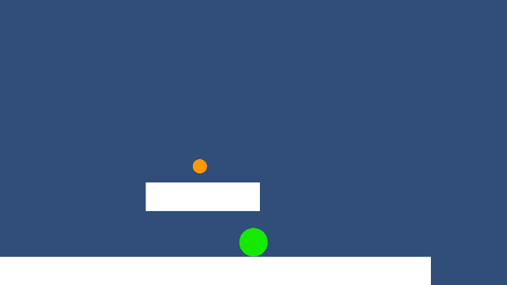

Camera: “leap of faith” camera angle is really low making it so that the player can not see what is beneath them. This created a feeling of anxiety when playing the game because the player could not see if they where going to land on a platform or a gap. The camera follows the player as the player moves with a slight delay. This element added to the feeling of anxiety because when falling from a high platform the player would disappear from the screen and if they fell into a gap, they would start the whole level from scratch.

The low camera angle is nice for that feeling of anxiety but combined with the camera delay it got frustrating sometimes when you could not see where the gap was that killed you. The game proved to hard.

Thus, the group decided to move the angle up a bit to give the player more vision of the platforms beneath them. This made the game much easier so the group decided to add moving platforms at the end of the level to give the feeling of a “boss” that needs to be completed before taking the final leap of faith.

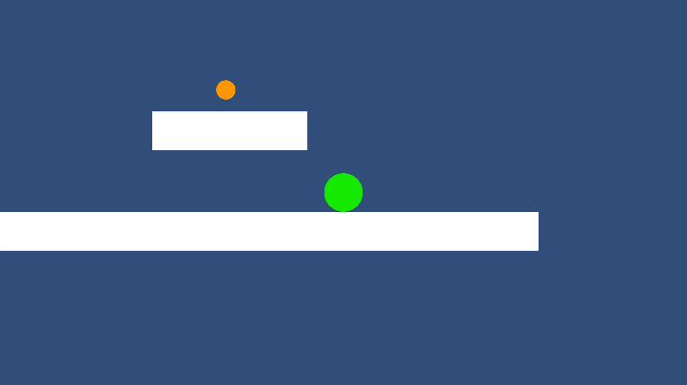

Other changes:

* End platform (have collected everything): stop movement. Tell the player they have won and give option to restart or go back to main menu. Stop player movement (if they have won.
* End platform (not collected all the collectables): when landing on the platform. Display a message telling the player to kill themselves and restart the level.
* Moving platforms. To enhance the difficulty of the game because the camera angle was moved up a bit.
* Timer. A timer is added that start from 0 and continues until the player is done with the level. In the main menu the latest time will be displayed.
* UI: take the curser away in game, bring it back when the pause menu or win menu pops up. Option to resume the game or exit the game in pause menu.

## **4 Post-Production**

* + Fixing the bugs/maybe not (We have Constraints)

## Reflection (Quality Assurance)

* What is our overall impression? (fun? Does it matter?)

## Reflection (Project Manager)

* Did we meet our Success Criteria?

This reflection will be guided by the group’s success criteria